**How to use WPF controls in DXCore Tool Window plug-in**

September 16th, 2011

[DXCore Tool Windows](http://www.skorkin.com/2010/08/dxcore-plug-ins-overview/) are based on the Windows Forms technology and can use only Windows Forms controls. However, if you would like to use WPF controls there is a work-around intended to use the [ElementHost](http://msdn.microsoft.com/en-us/library/system.windows.forms.integration.elementhost.aspx" \o "ElementHost" \t "_blank) Windows Forms control that is used to host a Windows Presentation Foundation (WPF) element.

There are four steps we should perform:

1. Create a new **DXCore tool window plug-in**
2. Add a new **WPF User Control** project
3. Implement the **WPF composite control**
4. Host the **WPF control** in the **DXCore plug-in**

**Step #1 – creating a new DXCore tool window plug-in**

To create a new **DXCore** plug-in, please read the appropriate article: [How to create a new DXCore plug-in](http://www.skorkin.com/2010/08/how-to-create-a-new-dxcore-plug-in/). Once the **DXCore** tool window is created (I have named it as *WPFToolWindow*), we can add a new *WPF User Control* project. In Windows Forms, we can host only a WPF element, so to make a new user control, we would use the Grid element in WPF and put the controls into it. In this sample, we will create a standard contact form and use the Text Box, Label and Button WPF controls.

**Step #2 – adding a new WPF User Control project**

* Right-click the plug-in solution in the *Solution Explorer*, and select *Add -> New Project*…

[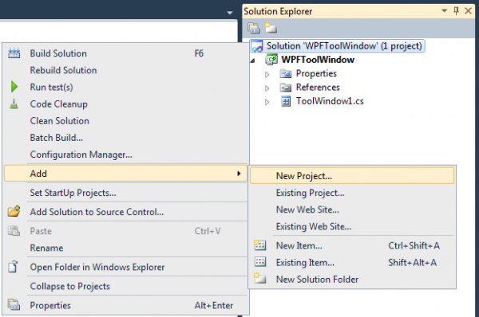](http://www.skorkin.com/files/2011/09/AddNewProjectMenuItem.png)

* Select the *WPF User Control* Library.
* Name the new project, e.g. *WpfControlLibrary* and click OK:

[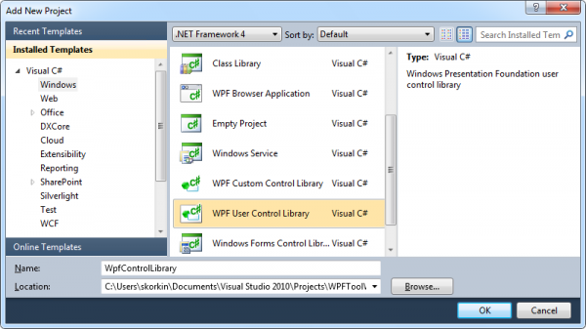](http://www.skorkin.com/files/2011/09/NewWPFUserControlLibrary.png)

* It would create *UserControl1.xaml* and *UserControl1.xaml.cs* in the new project.
* Inherit the *UserControl1* from the *Grid* element instead of the *UserControl*. As I stated, we cannot host a control – rather, we can host an element on the Windows Form. This change has to be done in both *UserControl1.cs*:

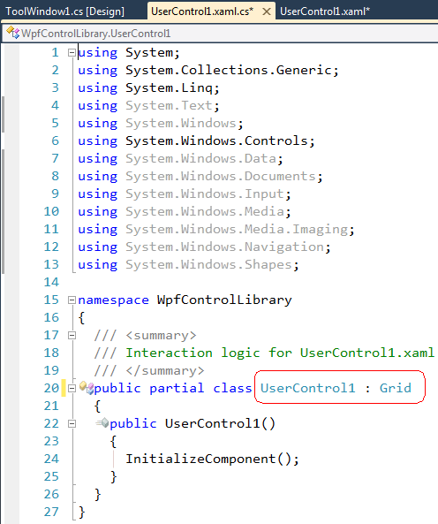

and *UserControl1.xaml.cs*:

[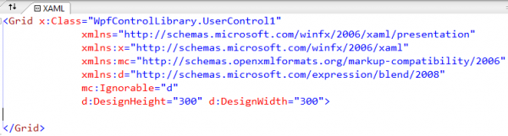](http://www.skorkin.com/files/2011/09/InheritingFromGridXAML.png)

**Step #3 – Implementing the WPF composite control**

* Drop and design WPF controls as required. For example, like this:

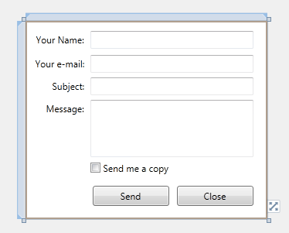

* Implement the controls logic as necessary.
* Build the *WpfControlLibrary* project.

**Step #4 – hosting the WPF control in the DXCore plug-in**

* Add a new reference to the **DXCore plug-in**:

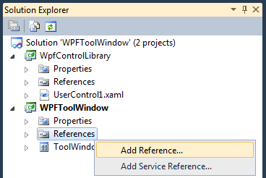

* Locate the *WpfControlLibrary* assembly and click OK to add it:

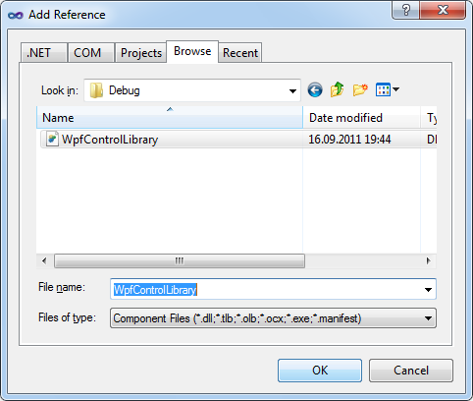

* Drop the *ElementHost* (from the *WPF Interoperability* tab) on the Tool Window design surface:

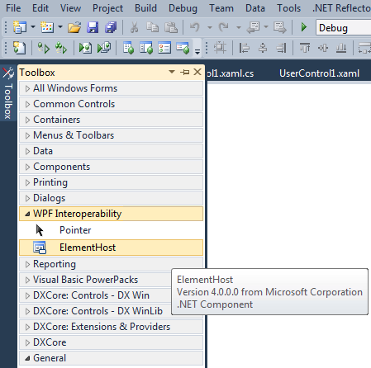

* Set the *Dock* property to *Fill* in the *elementHost1* control if necessary.
* Open up the tool window’s source code file, and create the class level variable of the *UserControl* type:

|  |  |
| --- | --- |
| 1 | WpfUserControlLibrary.UserControl1 \_WPFControl = null; |

* Add the following code to the *InitializePlugIn* method, to create an instance of the *WPF User Control* and attach it to the *Element Host*:

|  |  |
| --- | --- |
| 1  2 | \_WPFControl = new WpfControlLibrary.UserControl1();   elementHost1.Child = \_WPFControl; |

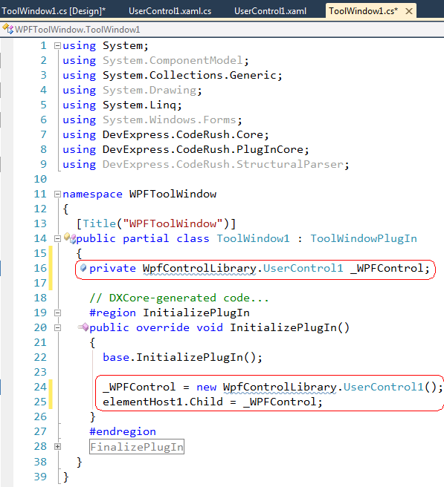

* Make sure that the tool window size is enough to display the WPF control, i.e. set its *MinimumSize* property.

Now, compile the solution and test the new tool window plug-in in a new instance of the Visual Studio:

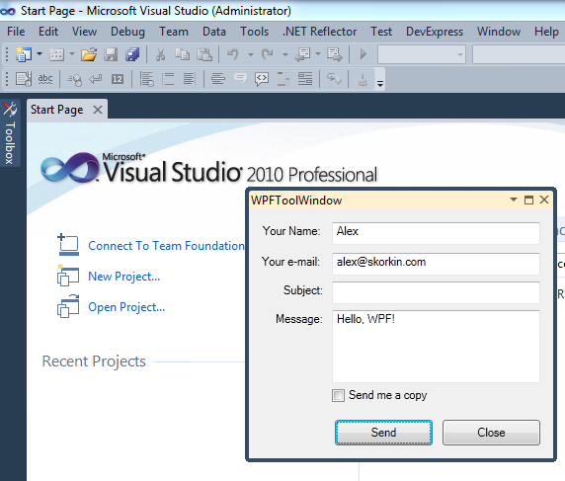

The sample plug-in is [attached](http://www.skorkin.com/files/2011/09/WPFToolWindow.zip) (20,125 bytes, C#, VS2010). If you have any questions or additions, please leave them as comments below to this blog post.